South Bersted CE Primary School

Church Lane
Bognor Regis
West Sussex
PO22 9PZ

Tel: 01243 821678
office@southbersted.co.uk
www.southbersted.co.uk
Headteacher: Mr Noel Goodwin

15th September 2026

Dear Parents and Carers
Year 6 Residential 2027 – Parent Information Meeting

We will be holding an information meeting to discuss the Year 6 residential trip which will take place on the 30th June until 2nd July 2027. The meeting will be held as follows:

Date: Friday 2nd October 2026
Time: 8.45am to 9.30am (in the hall)

During the meeting, Mr Thorn will explain the trip in more detail and will answer any questions you may have. Information packs will be given out during this session.

Please send a dojo message to the school office to confirm if you will be able to attend, no later than Wednesday 30th September. If you are unable to attend, an information pack will be sent home with your child afterwards.

Yours sincerely
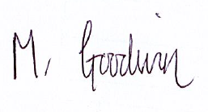

Mr Noel Goodwin
Headteacher

