South Bersted CE Primary School

Church Lane
Bognor Regis
West Sussex
PO22 9PZ

Tel: 01243 821678
office@southbersted.co.uk
www.southbersted.co.uk
Headteacher: Mr Noel Goodwin

Dear parents and carers,

Please find attached the September addition of our Online Safety Newsletter. This month's addition includes further information on the use of AI manipulated images, screen time and a link to access 'A guide for parents and carers on managing children’s digital lives.'

In addition to this, the latest online safety video has been uploaded to the school's website. This video and others can be accessed here: Online Safety – South Bersted Primary School.

If you have concerns related to something your child has accessed online, please speak to a member of the school's safeguarding team: Mr Goodwin, Mrs Bush, Mrs Robson and Miss Stanton.
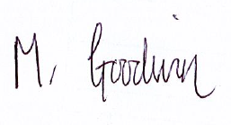
Yours faithfully,

Mr N Goodwin
Headteacher

