South Bersted CE Primary School
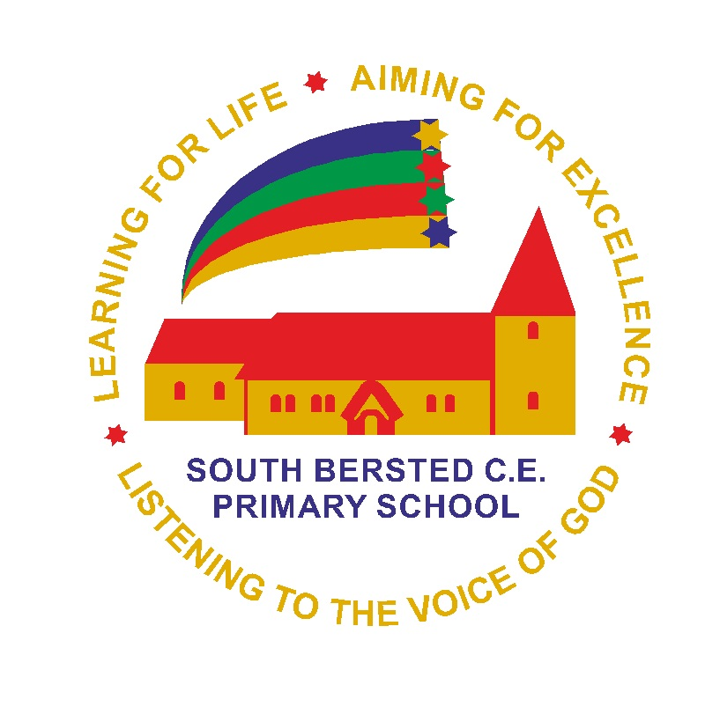
Church Lane
Bognor Regis
West Sussex
PO22 9PZ

Tel: 01243 821678
office@southbersted.co.uk
www.southbersted.co.uk
Headteacher: Mr Noel Goodwin

27th March 2023

Dear Parents and Carers,

Fairtrade Café – Easter Fair
Year 5 will be running a Fairtrade café at the Easter Fair on Thursday 30th March. We would like as many children as possible to stay to run the café from 3.15pm – 4.00pm. Please note, children will not be able to look around the fair if they are volunteering at the café, as there will be no school staff to supervise them.

If you would like your child to volunteer please complete the attached consent form and return it to the school office by Wednesday 29th March 2023.

Yours Sincerely,

For South Bersted School

YEAR 5 FAIRTRADE CAFÉ – EASTER FAIR THURSDAY 30TH MARCH 2023

Child’s name: _____________________
(please tick)

I give permission for my child to take part in the Fairtrade Café at the Easter Fair on Thursday 30th March 2023

I will collect my child from School at the end of the event (4.00pm)

OR

I give permission for my child to walk home alone at the end of the event

My emergency contact number is:

Signed: Parent / Guardian

