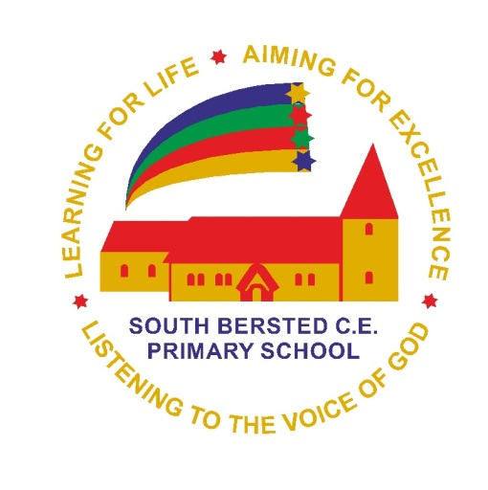 | South Bersted CE Primary  Attendance Policy Update  COVID-19 arrangements
Web and/or Internal | Internal & Web
This policy should be reviewed every | This policy is for use during the 2020-21 Academic Year
Policy approved by Governors | August 2020
Date of Review | As required
Member of staff responsible | Headteacher
Policy created by | SBS Policy
Signed by Chair of Governors and/or Headteacher

Introduction:
From September 2020, attendance is mandatory for all children and the local authority are encouraging all schools to follow their usual attendance procedures for children not attending. There are some circumstances where pupils cannot attend school due to coronavirus (COVID-19). These adaptions to the school’s attendance policy set clear expectations linked to attendance for the 2020 – 2021 academic year.
Attendance Expectations:
If a child is expected in school and does not attend, first day response processes will be followed, and subsequent actions taken in line with normal school attendance procedures. If we do not know where a child is being cared for, this becomes a safeguarding concern and will be followed up.
As stated in the school’s attendance policy, parents and carers will be contacted by the head teacher if a child’s attendance becomes a cause for concern.
At South Bersted Church of England Primary School, we expect all parents and carers to notify the school office on (01243) 821678 before 9:20am on any day when you child is too ill to attend.

Shielding:
The period of shielding for vulnerable adults/children ended on 1st August 2020, current guidance advises that parents and carers can now send their children to school.
Holidays:
We appreciate this summer has not been a typical one with the opportunities to get away for holidays. However, to support children’s learning, well-being and, for their development, they need to be in school every day. Missing out on more time in the classroom risks pupils falling further behind. Government guidelines now state that schools should be issuing Fixed Penalty Notices in line with local authorities’ codes of conduct.
Symptoms of COVID-19:
No one with symptoms of COVID-19 should attend school for any reason, and a test should be sought at the soonest available time.
If anyone in the household develops:
a high temperature – this means you feel hot to touch on your chest or back (you do not need to measure your temperature),
a new, continuous cough – this means coughing a lot for more than an hour, or 3 or more coughing episodes in 24 hours (if you usually have a cough, it may be worse than usual),
a loss or change to your sense of smell or taste – this means you’ve noticed you cannot smell or taste anything, or things smell or taste different to normal,

they are advised to follow the COVID-19: guidance for households with possible coronavirus infection guidance which states ‘If you have symptoms of COVID-19 however mild, you must self-isolate for at least 10 days from when your symptoms started. You should arrange to have a test to see if you have COVID-19 – go to testing to arrange’. All other household members must stay at home and not leave the house for 14 days. The 14-day period starts from the day when the first person in the household became ill or if they do not have symptoms, from the day their test was taken.
See Appendix 1 for actions linked to displaying symptoms of COVID-19.
Test and Trace:
At South Bersted Church of England Primary School, we are actively following the Government’s Test and Trace process. To ensure that we work together to reduce the risk of transmission, all members of the school’s community are expected to engage in the test and trace process. If a child has been advised to self-isolate through NHS Test and Trace, please let the school know. They must remain in isolation for the full 14-day isolation period. Even if they have a test which is negative, there is a chance they could still develop the coronavirus (COVID-19) within the remaining days.
Responding to a confirmed case:
If we suspect a child has a high temperature (of 37.8° or greater), their temperature will be taken using a digital thermometer. If their temperature is high, we will call parents/carers to collect and follow guidelines below.
Whilst a child is awaiting collection, they will be moved to the Rainbow Room, where they can be isolated until collected. The Rainbow Room door and windows will remain open for ventilation.
If we are notified that a member of staff or a pupil has tested positive, the school will contact the local Health Protection Team (HPT) which in this area is the South East of England. With the HPT, those who have been in ‘close contact’ will be identified, parents will be informed and children will be asked to self-isolate.
If two or more children or staff test positive for Covid-19 within a 2-week period, then this is classed as an “outbreak” and will be reported immediately to the Local Health Protection Team. The HPT may send a mobile testing unit into the school and have powers to close the school if necessary.
The COVID-19 section of the attendance policy was written with reference to the following documents:
https://www.gov.uk/government/publications/actions-for-schools-during-the-coronavirus-outbreak/guidance-for-full-opening-schools
https://www.gov.uk/government/publications/covid-19-stay-at-home-guidance/stay-at-home-guidance-for-households-with-possible-coronavirus-covid-19-infection#symptoms
https://www.gov.uk/guidance/coronavirus-covid-19-getting-tested
https://www.gov.uk/government/publications/school-attendance/addendum-recording-attendance-in-relation-to-coronavirus-covid-19-during-the-2020-to-2021-academic-year

Appendix 1:
Actions linked to Symptoms of COVID -19

What to do it… | Actions needed | Return to school when…
…my child has COVID-19 symptoms | Do not come to school.  Contact school daily.  Self-isolate.  Get a test.  Inform school immediately about the test result. | …the test comes back negative and your child feels well.
…my child tests positive for COVID-19 | Do not come to school.  Contact school daily.  Self-isolate for 10 days.  Get a test.  Inform school immediately about the test result. | …the 10 days have passed even if they have a cough or loss of taste as these symptoms can last for several weeks once the infection has gone.
…someone in my household has COVID-19 symptoms. | Do not come to school.  Contact school daily.  Household member to get a test .  Inform school immediately about the test result. | …the household members’ test is negative
…someone in my household has tested positive for COVID-19. | Do not come to school.  Contact school daily.  Isolate for 14 days. | …the 14 day isolation has passed form when the household member became ill, or if they did not feel ill the day the test was taken.
…NHS Test and Trace has identified my child as a close contact of someone with symptoms or a confirmed case of COVID-19. | Do not come to school.  Contact school daily.  Isolate for 14 days. | …the child has completed 14 days of isolation.
…we have travelled and have to self-isolate as part of a period of quarantine. | Consider quarantine requirements and advice from FCO when booking travel.  Do not come to school.  Contact school daily.  Isolate for 14 days. | …the child has completed 14 days of isolation.
…we have received medical advice that my child must resume shielding. | Do not come to school.  Contact school.  Shield until you are informed that the restrictions have lifted and shielding is paused again. | …school informs you that restrictions have been lifted.

